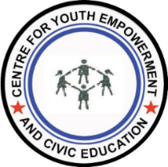
YOUTH RESEARCHERS’ ACADEMY (YRA) 2022
APPLICATION FOR PARTICIPATION IN THE YOUTH RESEARCHERS’ ACADEMY (YRA)

Please use the spaces provided. Information provided on additional pages will not be considered.

Biography
First Name
Last Name
Age
Gender (tick appropriate) | Male  Female  Other
Highest Level of Education (tick appropriate) | None  Primary  Secondary  Tertiary (Please indicate)  …………………………………………………………………..  …………………………………………………………………..  ……………………………………………………………………
Contact Number
Alternative contact number
Email address
Place of Residence
District
Tell us about Yourself (Max. 50 words)
(Qualifications and experience)
Are you affiliated to a youth organization, youth club or youth network? Yes No

(Provide detail of the youth work you are involved in) (Max. 50 words)
Why do you want to be part of the Youth Research Academy in Malawi? (Max. 200 words)
How do you think the youth Researchers Academy will benefit you and other young people in your community or the country at large? (Max. 150 words)
What are your expectations from the Youth Researchers Academy? (Max. 100 words)

Submission and deadline
Submission Deadline is 23rd March 2022. Please submit the application form together with your CV to CYECE offices in Lilongwe, Dedza, Salima, Mangochi and Machinga, or send to the following email address vacancies@cyecemw.org. Indicate on the email subject line or the envelope “Application for YRA 2022”

